Model Development Phase Template
Date | 20 June 2024
Team ID | 739900
Project Title | Predicting Permanent Magnet Resistance Of Electronic Motor Using Machine  Learning
Maximum Marks | 4 Marks

Initial Model Training Code, Model Validation and Evaluation Report
The initial model training code will be showcased in the future through a screenshot. The model validation and evaluation report will include classification reports, accuracy, and confusion matrices for multiple models, presented through respective screenshots.

Initial Model Training Code:
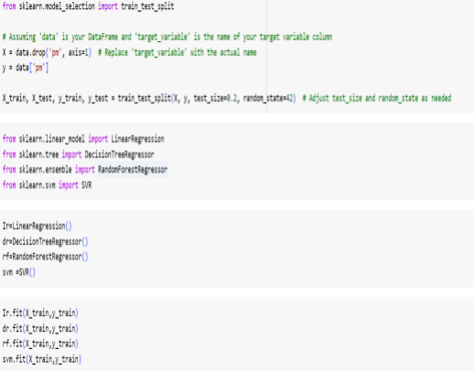
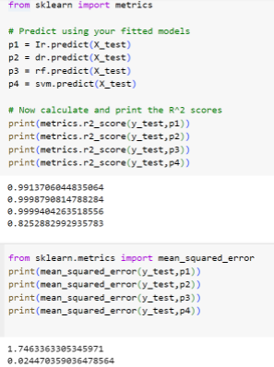

Model | Mean Squared Error


R2-Score

Decision tree,linear  regression,randomfore st regression | 